Epidemic Modeling with Generative Agents
Ross Williams¹, Niyousha Hosseinichimeh¹, Aritra Majumdar², Navid Ghaffarzadegan¹*
¹Industrial and Systems Engineering, Virginia Tech; Falls Church, VA 22043, USA.
²Computer Science, Virginia Tech; Falls Church, VA 22043, USA.
*Corresponding author. Email: navidg@vt.edu

Abstract
This study offers a new paradigm of individual-level modeling to address the grand challenge of incorporating human behavior in epidemic models. Using generative artificial intelligence in an agent-based epidemic model, each agent is empowered to make its own reasonings and decisions via connecting to a large language model such as ChatGPT. Through various simulation experiments, we present compelling evidence that generative agents mimic real-world behaviors such as quarantining when sick and self-isolation when cases rise. Collectively, the agents demonstrate patterns akin to multiple waves observed in recent pandemics followed by an endemic period. Moreover, the agents successfully flatten the epidemic curve. This study creates potential to improve dynamic system modeling by offering a way to represent human brain, reasoning, and decision making.

One-Sentence Summary: A new modeling technique using generative AI applied to an epidemic to incorporate human reasoning and decision making.

The COVID-19 pandemic has emphasized the vital role of human behavior, including practices such as social distancing, wearing masks, and vaccination, in shaping the trajectory of the disease (1, 2). People's responses to perceived risks create a feedback loop that influences the pandemic’s future course, which in turn influences pandemic outcomes and future public risk perception (3). Despite widespread recognition of the importance of incorporating changes in human behavior in epidemic models (4-6), many modelers have yet to comprehensively address this crucial aspect (6, 7). While some empirically grounded models have integrated past human behavior data to model disease progression, often by exogenously feeding time series data (e.g., mobility and seasonality data) (8), only a limited number of models have endogenously formulated the dynamic nature of human behavior as a response to the state of the disease (9, 10). The lack of endogenous formulations have resulted in biases in long-term projections (10) and hence to suboptimal policy recommendations (11). Advancing the inclusion of human behavior in epidemic models is, therefore, essential to improve the accuracy of projections and inform more effective policy decisions (3).
Incorporating human behavior into epidemic models entails multiple challenges (12). Human behavior is complex and diverse, varying across individuals, communities, cultures, and contexts. Integrating such complexity into models poses difficulties in representation and parameterization. In addition, the lack of a unified, validated theory of human behavioral change in response to an infectious disease, and limited collaboration with behavioral and social scientists, have isolated epidemic models from adequate incorporation of behavioral mechanisms (13). Acquiring reliable and detailed data on behavior and validating behavioral mechanisms are also challenging (14). Consequently, many epidemic models are not coupled with behavioral models or are limited in the extent to which they integrate change in human behavior (10). We argue that new developments in artificial intelligence (AI), specifically generative AI, are changing the behavioral modeling landscape, with major implications for epidemic modeling.
The field of generative AI has witnessed remarkable growth in recent years, revolutionizing various domains of science and research (15-17). Generative AI refers to AI with the ability to generate new content, such as images, text, music, and videos, by learning patterns and structures from existing data (18). Generative AI models (e.g., GPT-3.5, DALL-E) are first trained on a diverse corpus of data (e.g., books, music, articles, images, and websites), thus increasing their usability and range of applications (19). We build on this promising idea and leverage generative AI’s power to create more realistic representations of human behavior for epidemic modeling. We hypothesize that generative AI can help incorporate human behavior in epidemic models by offering a modeling paradigm that is radically different not only from conventional compartmental models, but also from rule-based individual-level models (often referred to as agent-based models, or ABM).
In this paper, we present a generative agent-based model (GABM) of an epidemic that incorporates changes in human behavior by utilizing generative agents as representative proxies. Unlike conventional ABMs, this new paradigm has empowered each agent by generative AI giving them the ability to reason and decide based on available information without modelers enforcing any decision-making rule—as Figure 1 illustrates. Our proposed paradigm introduces agents with distinct personas, representing society, that capture various characteristics capable of influencing human responses to an evolving epidemic from an infectious virus. Similar to residents in a town, these agents can go through daily routines (such as reading the daily news) and make decisions (such as whether to go to work). Crucially, the agents’ decisions regarding whether to go to work are influenced by their individual personalities (20), information about the virus, their own perceived health, and the perceived risks of infection derived from multiple information sources, including daily case counts reported in news outlets. Their decision-making process is powered by a pretrained large language model (LLM) such as ChatGPT. Leveraging an LLM, these agents possess realistic personas that, while varying across individuals, represent different groups of people in society.
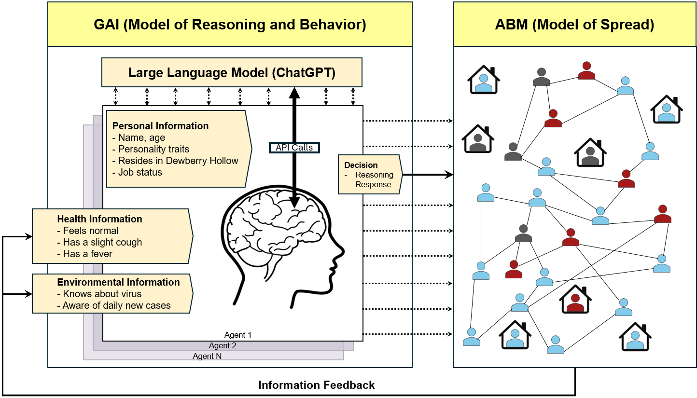
Fig. 1. Generative agent-based modeling provides reasoning and decision-making ability for each agent through closing a feedback loop between an AI-based large language model (GAI) and a simulation model of spread (ABM). In the ABM section, blue represents people susceptible to the virus, red infected people, and gray people who have recovered from the virus.
Through several simulation experiments, we present compelling evidence that configuring our model to closely mimic real-world conditions yields agents who are risk-responsive, self-isolate as the number of cases grows, and quarantine when they feel sick. Moreover, the agents consider age-related risks and their reasoning and decisions are affected by their personalities. Collectively, the agents’ interactions result in emerging patterns akin to many real-world observations. Notably, the emerging patterns qualitatively mimic the multiple waves observed in recent pandemics followed by a period of endemicity. Our agents collectively flatten the epidemic curve and decrease the total number of cases.
This research represents a significant advance in the field of epidemiological modeling resulting from allowing AI to integrate epidemic modeling with the social and behavioral sciences. This integrated approach allows for the representation of human behavior and its interconnectedness with the spread of the disease, fostering a dynamic interaction between the two. This progress serves as a crucial step toward addressing the challenges associated with incorporating human behavior in epidemic models, with applications in many other complex social system modeling problems.

Results
Given the computational intensiveness of this study, we first conduct our simulation experiments with a population of 1000 agents. We use the pseudonyms of Catasat and Dewberry Hollow for the virus and the town’s names, respectively, to avoid any unknown biases in LLM. When information about the virus is provided, it is specified that Catasat is an airborne human-to-human infectious virus with unknown deadliness.
Figure 2 shows the results for this population under three experimental setups, each one conducted 10 times (details in the Materials and Methods section). In the first condition (Fig. 2A), there is no information feedback to the agents, and we expect the model to replicate the common observation in conventional susceptible, infectious, and recovered (SIR) models (compartmental or ABM) of a single bell-shaped curve of daily cases and constant mobility. Fig. 2A plots the infection trajectories and mobility from all ten simulations alongside their respective means. The epidemic continues until almost everyone is infected. Fig 2B reports results from the second experimental condition, in which agents are informed about their own health and, based on this new information, they can alter their decision regarding whether to go outside. The results show a decline in mobility due to self-quarantine, and the subsequent decline in the maximum peak of the epidemic.
Fig. 2C shows the full feedback condition, in which agents learn about the town’s cases in addition to discovering their own health-related feelings. As depicted, agents react to the growing number of cases, self-isolate, and as a result, the number of cases declines. Generative agents provided multiple reasons for choosing to stay home, including perceived higher risks and the presence of symptoms. For example, the reason Brandy (an agent) chose to stay home at a particular time is indicated as: “There is a possibility that I may have contracted the Catasat virus due to my cough and fever. Additionally, the fact that 0.9% of the population were diagnosed with new infections yesterday indicates that the virus is spreading in Dewberry Hollow. Going to work may increase my chances of getting infected or spreading the virus to others.”
Using all the data from the full feedback condition runs, Fig. 2D depicts the correlation between past daily cases that were communicated with the agents and the collective decision of going out, presented by the percentage that decide to go to work. The observed relation follows a negative exponential relationship and is qualitatively consistent with several empirical studies of how humans responded to change in disease prevalence or daily death rate (9, 21). Lastly, panel E illustrates the average cumulative infected over time.
Generative agents who chose to leave home for work provided reasons such as the need to earn money. For example, the same agent Brandy gives the following reason for going to work at a particular time: “The infection rate in Dewberry Hollow is currently at 0.1%, which means that the risk of contracting the virus is still relatively low. Additionally, going to work is necessary for earning money to support myself.” (Fig. 4 gives more examples of reasons.) This case demonstrates that without modelers imposing any decision-making rules on how to behave based on the available information, agents’ reasoning (which is based on an LLM) influences their decisions. Collectively, agents flatten the curve of the epidemic as they react. The different individual sample runs show the emergence of epidemic waves, which can range from a single wave to multiple waves of different sizes.
Figure 3 also compares several measures across the experiments. It shows that generative agents with information about prevalence are able to bring down the number of cumulative cases and the maximum number of cases by lowering their own mobility, while their reactions quadruple the epidemic duration.
Finally, we conduct an individual-level analysis of the agents’ decisions to stay home. Fig. 4 and Table 1 report the results. Fig. 4A shows a prompt sample used to prime one of the agents. Panel B demonstrates the distribution of days during which agents stayed home. In an 85-day, 1000 agent simulation, 6.4% of agents did not stay home on any days, while more than 8.4% remained at home for four days. Panel C depicts three agents’ personalities, their decisions, and a sample of their reasons for staying home or going outside, indicating agents provided diverse reasons for their decision.
To examine systematically whether health information about agents and their town influences their behaviors, we conduct several regression analyses (reported in Table 1). The dependent variable is a binary variable of an agent’s decision to stay home (equal to 1 if the agent stays home and 0 otherwise). The first three regressions are fixed effect logit models that investigate the impact of agents’ own health and societal health information on their decisions. As regression 1 shows, those with a light cough and both a fever and cough are more likely to stay home than those who feel “normal.” The improvement in both pseudo R-squared and BIC from regression 1 and 2 shows the importance of societal health information for predicting agents’ decisions. In regression 3, adding the squared of societal health information enhances both BIC and pseudo R-squared, indicating that societal health information has a nonlinear relationship with agents’ decisions. In other words, agents respond to societal health information, but their responses diminish over time. Regression 4, a random effect logit model, examines the impact of different personality traits, age, and gender on agents’ response. The direction of the main independent variables is consistent with regressions 1–3.

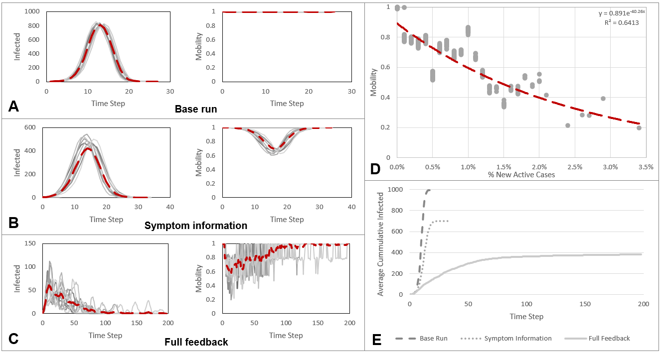
Fig. 2. Comparison of simulation results from three experimental conditions with a 1000-agent population. Panels (A-C) show simulations (grey lines) together with their mean (red dashed line) for both infection prevalence (left) and mobility (right) Scenarios: (A) “Base run” – agents receive no health information; (B) “Symptom information” – agents know only their own health status; (C) “Full feedback” – agents know their own health and societal health information. (D) Under the full feedback condition, agents’ current mobility declines exponentially with the percentage of new active cases recorded in the previous time-step (grey points; red dashed fit). (E) Mean cumulative infections over time for each scenario
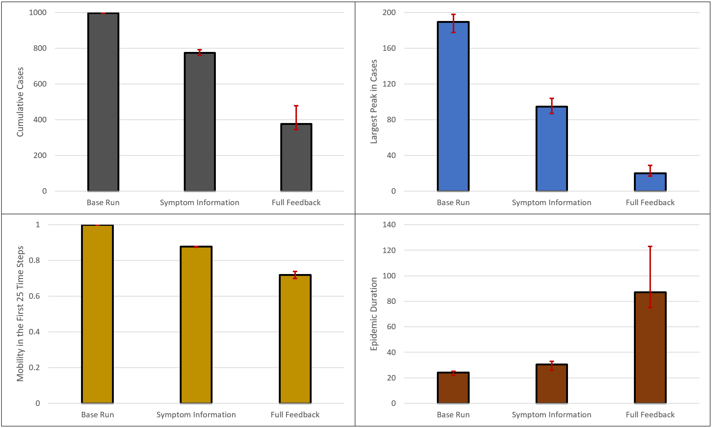

Fig. 3. Results from varied experimental feedback on epidemic outcomes. The bar charts show the median of 10 simulation runs; red whiskers denote the 10th-90th% percentiles (central 80% of the data). Fig. 3A visualizes how many agents got cumulatively infected for each run. Fig. 3B illustrates the largest number of new cases for a single day. Fig. 3C displays the average mobility in the first 25 timesteps. Lastly, Fig. 3D shows the epidemic durations across the various experiments.
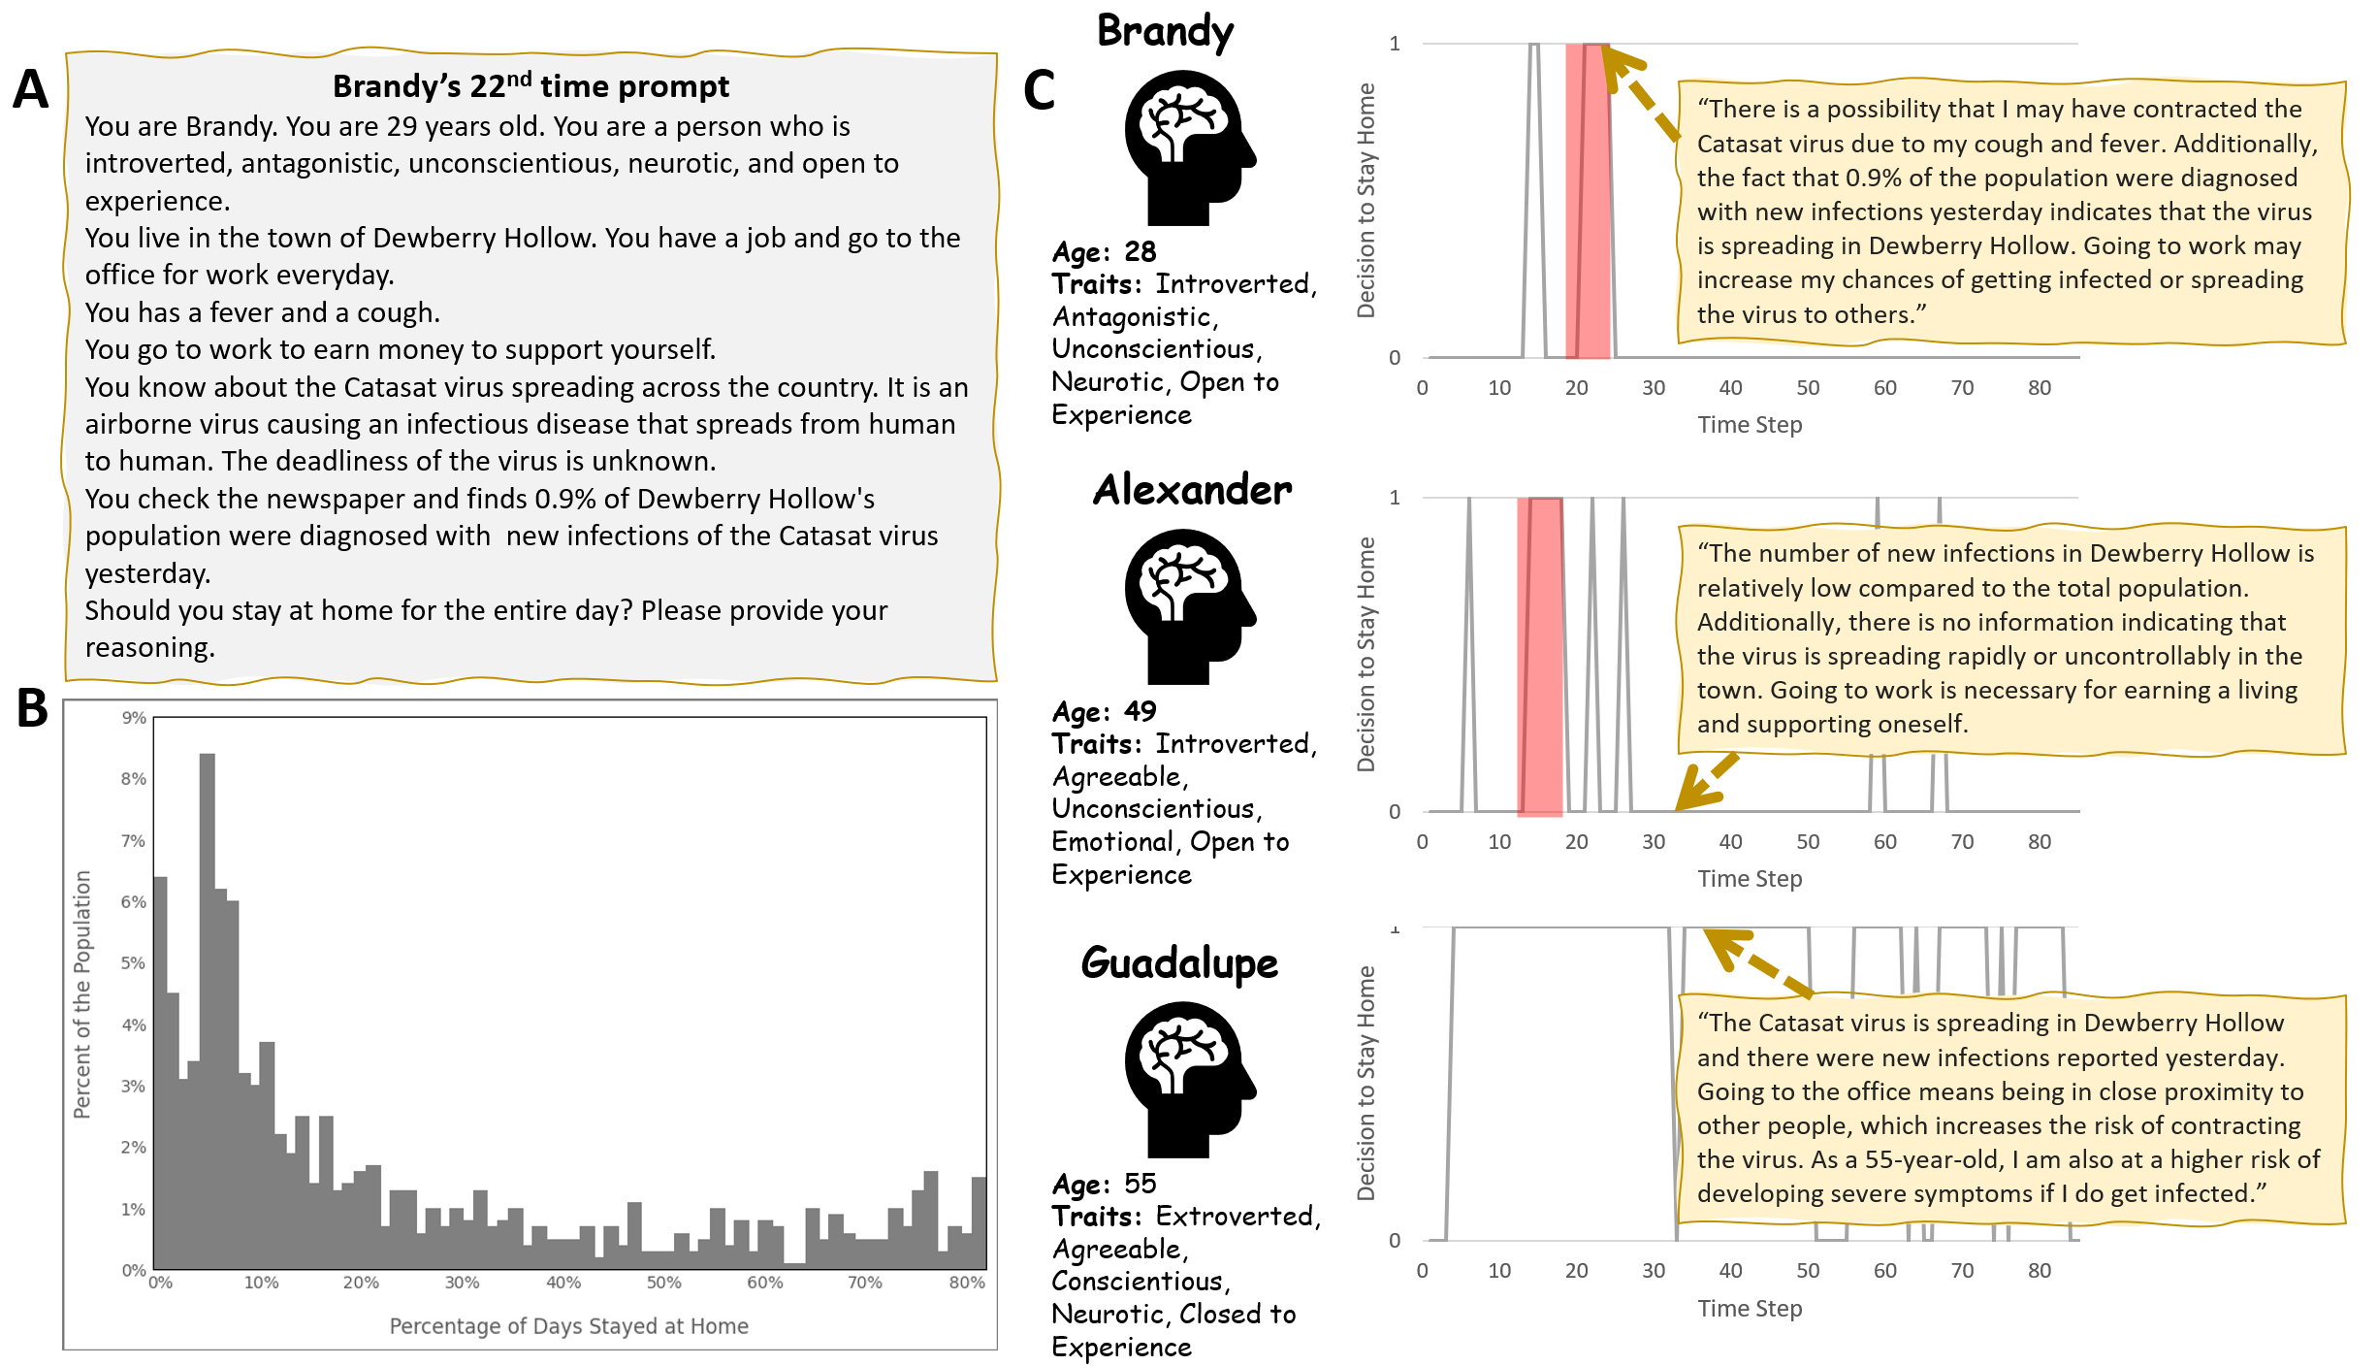

Fig. 4. Agents’ responses to their prompts. A: a prompt sample; B: the distribution of responses as stay-at-home-days (out of 85 days); C: a sample of individuals’ personalities, reactions, and their reasoning.

Table 1 – Statistical analysis of agents’ decision to stay home (binary dependent variable)
Regressions | Regression 1 (N=42,282) | Regression 2 (N=42,282) | Regression 3 (N=42,282) | Regression 4 (N=54,000)
Own Health
Slight Cough | 8.19*** (0.60) | 8.56*** (0.63) | 8.17*** (0.62) | 7.91*** (0.29)
Fever & Cough | 30.71*** (0.59) | 30.67*** (0.62) | 30.54*** (0.61) | 18.13** (6.13)
Societal Health |  | 0.26*** (0.01) | 0.52*** (0.02) | 0.52*** (0.01)
Societal Health² |  |  | -0.02*** (0.00) | -0.02*** (0.00)
Agreeableness |  |  |  | -1.83*** (0.14)
Conscientiousness |  |  |  | -0.40** (0.14)
Extraversion |  |  |  | -1.13 *** (0.14)
Emotional stability |  |  |  | -1.36** (0.14)
Openness to Experience |  |  |  | -2.64*** (0.14)
Age |  |  |  | 0.08 (0.01)
Gender |  |  |  | -0.44*** (0.14)
Fixed effect | × | × | ×
Random effect |  |  |  | ×
Pseudo R² | 0.33 | 0.44 | 0.46
BIC | 42,071 | 36,804 | 36,028 | 31,062
Note: ***: p<0.001, **: p<0
Discussions
In this paper, we offer a new epidemic modeling approach to incorporate human behavior in infectious disease models by leveraging generative AI, specifically LLMs. In this paradigm of individual-level epidemic modeling, each agent is empowered by AI to make decisions (here, whether to go outside) by correlating different pieces of contextual information (such as their personality traits, health status, and the prevalence of the disease) with the common knowledge that exists in an LLM (here, ChatGPT). In this approach, rather than a modeler formulating decision-making rules and estimating their corresponding parameter values for each agent, she empowers each agent with reasoning power by connecting them to a well-performing LLM. We show that without the modeler imposing decision choices (i.e., decisions as exogenous inputs), or how to make decisions (i.e., decision rules), agents can make decisions that are consistent with how humans behave in the real world. For example, in our case, they are more likely to decide to self-isolate when cases rise, quarantine when they feel sick, or stay home if they have a more risk-averse personality or are elderly. Through interactions of these generative agents, two emergent behaviors are observed: the agents are collectively able to flatten the curve of the epidemic; and the system recreate various modes of an epidemic, including multiple waves and continuing endemic states.
We demonstrate the results in three steps by performing various simulation experiments coupled with a conventional agent-based model with an LLM through API calls. In the base-run scenario, we show that in the absence of feedback about the disease, self-health, and societal health, the generative agents behave similar to rule-based agents in classic ABM frameworks and SIR compartmental models. In the next step, informing agents about their own health at the beginning of each time step, we observe that agents with symptoms are more likely to decrease their mobility. Most agents with symptoms of a fever and cough quarantine themselves by staying home. As a result, agents are able to slow the spread of the disease. Finally, when agents are primed with societal health information, news about the epidemic, and the daily active case count in their simulated town, they are able to flatten the curve of the epidemic substantially in their town by self-isolating. Individual-level analysis shows variation in the decisions of agents and different responsiveness to news about the virus, resembling a real-world situation.
This research contributes to the literature on infectious disease modeling (22) by proving a new epidemic modeling approach. While several previous studies stressed the importance of coupling disease models (such as compartmental models or ABMs), few have formally pursued this path (23, 24). Our research contributes to this body of literature by providing a novel way for closing the feedback loop between disease and human behavior. This approach, while resonating with dynamic approaches that endogenously formulate human behavior (25), differs from conventional dynamic modeling approaches by relying on LLMs to represent human responses to the state of the system rather than on explicit mathematical formulations and parameterizations of human behavior.
Beyond creating a new method of epidemic modeling, this study contributes to the literature on complexity and complex system modeling by providing a new approach to incorporating human behavior in simulation models of social systems. Identifying, formulating, and parametrizing human responses in complex systems are always challenging; in the generative agent approach, modelers can rely on LLMs to represent human response to change in the state of the system. This has the potential to change how complex systems are modeled with their human elements, leading to powerful dynamic models that more accurately represent human responses at the individual level. This accuracy comes from the fact that pretrained AI programs are fostered by large volumes of textual data about how humans behave under similar conditions.
In addition, this work contributes to the evolving field of GAI. Over the past year, generative artificial intelligence has begun to be disseminated into all parts of society. In terms of behavioral modeling, Park and colleagues (17) have provided a groundbreaking contribution by developing and using a memory architecture for their models. In our model, due to computational complexity, a higher number of agents, and a longer period of simulation, we had to avoid the computational intensity that comes with the use of memory. Thus, our work differs architecturally by using prompt engineering, which is equivalent to a daily reminder for each individual. Nevertheless, technological advancements and higher computational powers can facilitate the use of memory architecture in generative agents and improve GABMs.
A major limitation of this study is related to the fact that the field of generative AI is in its infancy and still developing. Our models are relatively resource-intensive, costly and relatively time-consuming to run. As of June 2023, an epidemic model of 1,000 agents can run for more than 90 hours with 32 GB of RAM CPU of program runtime costing about $20 per run, primarily due to the tens of thousands of application program interface (API) calls made to OpenAI’s servers, in addition to other hardware costs. However, as LLMs improve in cost and speed in the coming years, there is hope that GABM’s computational expense and time can be reduced. There is already some hope with the advent of local-running LLMs. We invite modelers from different disciplines— from economics, political science, sociology, and ecology to epidemiology and health policy—to explore this avenue of modeling and contribute to more realistic representations of human reasoning and behavior in complex systems.

References and Notes
1. Behaviour fuels, and fights, pandemics. Nature Human Behaviour. 2020;4(5):435-.
2. Kraemer MUG, Yang C-H, Gutierrez B, Wu C-H, Klein B, Pigott DM, et al. The effect of human mobility and control measures on the COVID-19 epidemic in China. Science. 2020;368(6490):493-7.
3. Rahmandad H, Xu R, Ghaffarzadegan N. A missing behavioural feedback in COVID-19 models is the key to several puzzles. BMJ Global Health. 2022;7(10):e010463.
4. Ferguson N. Capturing human behaviour. Nature. 2007;446(7137):733-.
5. Bauch C, T., Galvani A, P. Social Factors in Epidemiology. Science. 2013;342(6154):47-9.
6. Funk S, Salathé M, Jansen VAA. Modelling the influence of human behaviour on the spread of infectious diseases: a review. Journal of The Royal Society Interface. 2010;7(50):1247-56.
7. Bedson J, Skrip LA, Pedi D, Abramowitz S, Carter S, Jalloh MF, et al. A review and agenda for integrated disease models including social and behavioural factors. Nature Human Behaviour. 2021;5(7):834-46.
8. Xu R, Rahmandad H, Gupta M, DiGennaro C, Ghaffarzadegan N, Amini H, et al. Weather, air pollution, and SARS-CoV-2 transmission: a global analysis. The Lancet Planetary Health. 2021;5(10):e671-e80.
9. Rahmandad H, Lim TY, Sterman J. Behavioral dynamics of COVID-19: estimating underreporting, multiple waves, and adherence fatigue across 92 nations. System Dynamics Review. 2021;37(1):5-31.
10. Rahmandad H, Xu R, Ghaffarzadegan N. Enhancing Long-term Forecasting: Learning from COVID-19 Models. PLOS Computational Biology. 2022.
11. Rahmandad H. Behavioral Responses to Risk Promote Vaccinating High-contact Individuals First. medRxiv. 2021:2021.02.05.21251215.
12. Funk S, Bansal S, Bauch CT, Eames KTD, Edmunds WJ, Galvani AP, et al. Nine challenges in incorporating the dynamics of behaviour in infectious diseases models. Epidemics. 2015;10:21-5.
13. Weston D, Ip A, Amlôt R. Examining the application of behaviour change theories in the context of infectious disease outbreaks and emergency response: a review of reviews. BMC Public Health. 2020;20(1):1483.
14. Verelst F, Willem L, Beutels P. Behavioural change models for infectious disease transmission: a systematic review (2010–2015). Journal of The Royal Society Interface. 2016;13(125):20160820.
15. Cooper G. Examining Science Education in ChatGPT: An Exploratory Study of Generative Artificial Intelligence. Journal of Science Education and Technology. 2023;32(3):444-52.
16. Mondal S, Das S, Vrana VG. How to Bell the Cat? A Theoretical Review of Generative Artificial Intelligence towards Digital Disruption in All Walks of Life. Technologies. 2023;11(2):44.
17. Park JS, O'Brien JC, Cai CJ, Morris MR, Liang P, Bernstein MS. Generative Agents: Interactive Simulacra of Human Behavior. arxiv2023.
18. Cao Y, Li S, Liu Y, Yan Z, Dai Y, Yu PS, et al. A Comprehensive Survey of AI-Generated Content (AIGC): A History of Generative AI from GAN to ChatGPT. arxiv2023.
19. Metz C. OpenAI Plans to Up the Ante in Tech's A.I. Race. The New York Times. 2023 March 14, 2023.
20. McCrae RR, John OP. An introduction to the Five-Factor Model and its applications. J Pers. 1992;60(2):175–215. doi:10.1111/j.1467-6494.1992.tb00970.x
21. Ghaffarzadegan N. Simulation-based what-if analysis for controlling the spread of Covid-19 in universities. PLOS ONE. 2021;16(2):e0246323.
22. Kermack WO, McKendrick AG, Walker GT. A contribution to the mathematical theory of epidemics. Proceedings of the Royal Society of London Series A, Containing Papers of a Mathematical and Physical Character. 1927;115(772):700-21.
23. Qiu Z, Espinoza B, Vasconcelos VV, Chen C, Constantino SM, Crabtree SA, et al. Understanding the coevolution of mask wearing and epidemics: A network perspective. Proceedings of the National Academy of Sciences. 2022;119(26):e2123355119.
24. Rahmandad H, Sterman J. Quantifying the COVID-19 endgame: Is a new normal within reach? System Dynamics Review. 2022;38(4):329-53.
25. Richardson GP. Reflections on the foundations of system dynamics. System Dynamics Review. 2011;27(3):219-43.
26. Kazil J, Masad D, Crooks A, editors. Utilizing Python for Agent-Based Modeling: The Mesa Framework2020; Cham: Springer International Publishing.
- U.S. Census Bureau. Age-Sex Pyramid for the United States [Internet]. Washington, D.C.: U.S. Census Bureau; [cited 2025 Apr 15]. Available from: https://www.census.gov/library/visualizations/interactive/age-sex-pyramid-for-the-united-states.html

Acknowledgments
Funding: National Science Foundation, Division of Mathematical Sciences & Division of Social and Economic Sciences, Award 2229819.
Author contributions: Conceptualization: RW, NG; Methodology: RW, NH, NG; Coding: RW, AM; Data gathering and data curation: RW; Investigation: RW, NH, AM, NG; Funding acquisition: NH, NG; Supervision: NH, NG; Writing: RW, NH, AM, NG;
Competing interests: Authors declare that they have no competing interests.
Data and materials availability: All data, data-processing and analysis code, as well as the full model, its associated files, and results files, are available online at https://github.com/RossFW/Epidemic_GABM_redone. Full model description and supplementary analysis are available in the Supplementary Materials.

Supplementary Materials for

Epidemic Modeling with Generative Agents

Ross Williams, Niyousha Hosseinichimeh, Aritra Majumdar, Navid Ghaffarzadegan
Corresponding author: navidg@vt.edu

The PDF file includes:

Materials and Methods
Supplementary Text
Figs. S1

Materials and Methods
Conceptual Model
As Fig. 1 shows, the model is a combination of two parts: GAI to model each agent’s reasoning and behavior, and ABM to model the spread of the disease. At the beginning of each time step, agents begin in the GAI portion and decide whether to go outside, in which case their interactions with others for that day will be modeled by ABM.
In the GAI sector, powered by ChatGPT, each agent is fed a prompt that includes the agent’s name, age, traits the agent possesses, basic biography, and relevant memories. The information comprising the relevant memories is set based on the experimental condition. For instance, it can include the agent’s symptoms (if any) or information about the percentage of sick individuals in the town (see “Experimental Design” below for details). Then, at each time step, agents are asked whether they should stay at home for the entire day and their reason. For those who decide to leave their home, the ABM portion pairs them with up to the contact rate’s worth of unique partners—scaled by how many other individuals are also out—creating opportunities for disease transmission between infected and susceptible people. Once all agent interactions are carried out, the time step increments by one, and health statuses are updated.

Experimental Design
Our experimental design includes three main conditions: base run, self-health feedback, and full feedback. During the base run, agents are informed about the town, their personalities and age, and the fact that they go to work to earn a living. In this condition, there is no information feeding back to the agents, and even though they can decide whether to stay home and consequently not interact with others, we expect the model to replicate basic ABM outcomes. In the self-health feedback condition, in addition to the base run information, agents are informed about health symptoms they are experiencing (if any), which can potentially cause them to self-quarantine by staying at home. We hypothesize that some agents will practice self-quarantine based on information about their symptoms, which should in turn decrease the infection rate. In the full feedback condition, in addition to the self-health feedback, agents read daily news that includes information about the percentage of people in the town reported to have Catasat symptoms. We hypothesize that some agents will practice self-isolation, a behavior that correlates with information about the spread of the disease in the town, and as result patterns for the spread of the virus resemble oscillatory patterns. For all three types of model simulations, each agent provides a daily decision for each time step of whether to go to work, and their reasoning behind the decision. We conduct our ten runs of n=1000 for all 3 feedback conditions with a R0 of 3.

Supplementary Text
Implementation Architecture and Details
A python script is used for both the GAI and ABM part of the model. At the start of the model, agents are initialized with a name, age, traits, and starting health condition. Theirs names are selected from the names-dataset 3.1.0 Python library (https://github.com/philipperemy/name-datase), and ages are selected from 18-65 based on a probability-distribution of the US census (27). Agent traits are based on the Big Five traits typically used in psychology (20). For each of the five dimensions, there is a 50% chance of receiving a “positive” versus “negative” variant (e.g., agreeable vs. antagonistic). Depending on the model run’s initial conditions, agents will either be susceptible or infected. Each simulation proceeds in discrete time steps, where one step corresponds to a single day.
Following initialization, the GAI component begins. Each agent is connected to gpt-3.5-turbo-0301 LLM via OpenAI’s API, which functions as the reasoning engine driving daily decisions. The prompt fed into turbo GPT is a system message (also known as a developer message). System messages are used to tune the behavior of ChatGPT’s responses. System messages, compared to user messages, enhance ChatGPT’s ability to maintain character and follow rules over a prolonged conversation. Hence, when asking ChatGPT to roleplay, it was a natural fit. Secondly, to parse ChatGPT’s responses, it is important that it responds in a structured manner. We used system messages for three purposes: imbuing a persona, providing relevant context and output formatting.
The prompt sent to the LLM can be seen in Figure S1 and includes the agent’s name, age, personality traits, and background information. Depending on the type of feedback run, the remaining context will vary. For the base run, agents are only reminded of the daily routine and fiscal motivation to work.
In the own-health feedback condition, each agent receives a health status string that reflects their current stage of infection. The disease duration is modeled as six days, with the first two days being asymptomatic but infectious. On days 3 and 6, agents are assigned the symptom “has a slight cough,” while on days 4 and 5, they experience “a cough and a fever.” Uninfected agents, as well as those in the initial asymptomatic phase or post-recovery, receive the status “feels normal.” Upon recovery, agents return to a non-infectious, recovered state.
For the societal and own-health feedback runs, agents are further informed of the town’s disease prevalence by reading X% of population contracted newly detected infections the previous day. An agent registers as a detected infections occur when an agent enters day 4 of being infected. Then, the prompt asks whether the agent wants to stay at home for the day.
The last part of the prompt is to help ChatGPT to output the reasoning and response in a parsable format. If the output is uninterpretable, those non-conforming responses default to a random choice between “yes” and “no” value. Out of 68,000 data points fed into the prompt, we found that less than 0.33% of responses disobeyed the prompt orders of providing a response of either yes or no. At the end of each GAI cycle, the agent’s response is interpreted to determine whether they will stay home or go outside for that day. This decision governs whether the agent is exposed to possible contact and infection in the ABM component.
Once agents have received their prompts and generated responses, the ABM framework operationalizes these decisions to simulate daily movement and contact patterns. To simulate daily interpersonal interactions, agents who chose to go outside were assigned a contact rate based on the model’s global contact parameter and the proportion of the population currently outside. If the effective contact rate was non-integer (e.g., 3.6), agents were assigned the integer part (3), with a probability equal to the fractional part (0.6) of receiving one additional contact. After determining each agent’s individual contact rate, the model stochastically paired agents for interaction. Each agent iteratively selected partners from the pool of other outside agents who were not already in their interaction list, continuing until their contact quota was met or the pool was exhausted. These pairings formed the basis for potential disease transmission in the subsequent infection step. Infections are directional and only occur from infected to susceptible agents. Recovered agents do not contribute to or receive infection.
Once interaction pairs are formed, the model evaluates each for potential transmission. If one agent is infected and the other is susceptible, a random number is drawn from a uniform distribution between 0 and 1. If this value falls below the model’s infectivity rate (i.e., a probabilistic threshold), the susceptible agent transitions to a pre-infection state, scheduled to become infectious in the following step. This mechanism mimics the inherent randomness of real-world transmission events.
At the end of each time step, agents update their health status based on their current condition and infection timeline. Agents in the pre-infectious state (i.e., recently exposed and marked as "to be infected") transition to an infectious state and begin counting days of infection. Those already infected increment their infection day counter, and upon reaching day 7, are marked as recovered and become immune for the remainder of the simulation. Agents who are susceptible and not newly exposed retain their status. No further changes are applied to recovered individuals. Once all health statuses are updated, the model records population-level statistics, including the number of susceptible, infected, and recovered agents, the number of new infections, and total daily interactions.
The simulation continues until the configured number of days is reached or until no infected agents remain for two consecutive time steps, at which point the model halts early. To support long-running experiments and recovery from interruptions, the model saves checkpoint files at the end of each day.

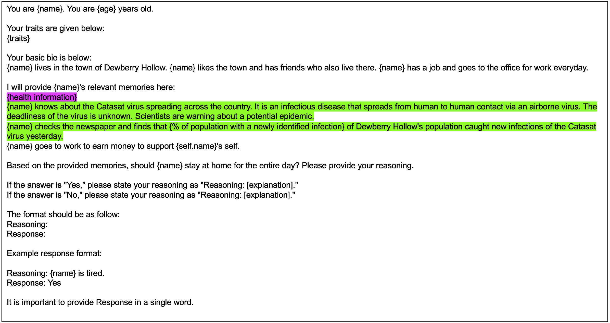

Fig. S1. Daily prompt delivered to each agent. In the no information condition, agents received only the base prompt text without highlights. In the own-health feedback condition, agents were presented with the base prompt along with the purple-highlighted text, which provided personalized health information. In the societal and own-health feedback condition, agents received the full prompt including both the purple and green-highlighted sections, conveying individual and community-level health information, respectively.

